Graph Coloring Problem

Abstract
This article presents our implementation of various solutions and optimizations for the Graph Coloring Problem (GCP) using Cultural Algorithm (CA) and Backtracking. We describe the design and implementation of the algorithms, the conducted experiments, obtained results, and the corresponding analysis and discussion. Additionally, we provide an overview of the applied algorithms, detailing their main functionalities and explaining how each of them operates.

Keywords: Chromosome, Belief, Population, Backtracking

Introduction
This project addresses the Graph Coloring Problem (GCP) using two distinct approaches: Backtracking and the Cultural Algorithm (CA), both implemented in Python. The goal is to demonstrate that a single problem can be solved using multiple algorithms, each producing different types of results. While the Backtracking approach guarantees a valid chromatic number, it does not always yield the minimal one. In contrast, the Cultural Algorithm consistently aims to find the minimum chromatic number by starting with an estimated value and progressively improving it through its belief space mechanism.

Cultural Algorithm

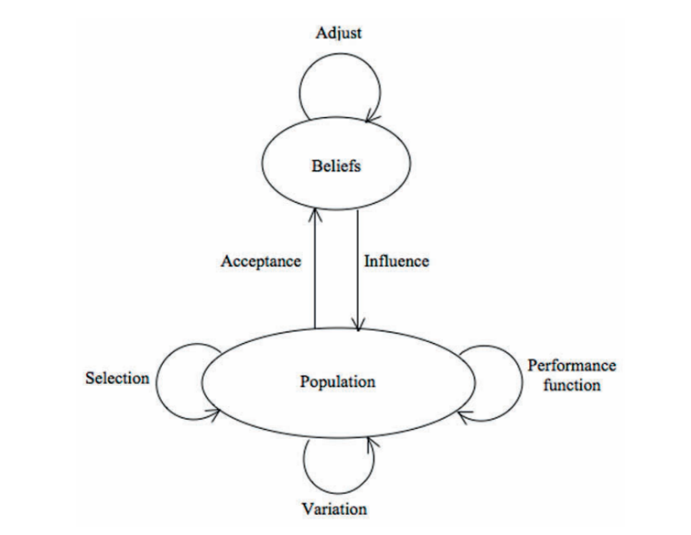
2.1 Basic Concepts of Cultural Algorithm
Figure 1 – Illustration of Cultural Space
Cultural algorithms were developed by Robert G. Reynolds as a complement to the metaphor adopted by evolutionary algorithms, which was mainly focused on genetic concepts and on the natural selection mechanism (Reynolds 1994). Cultural evolution can be seen as an inheritance process that occurs at two levels: micro-evolutionary level (Population Space) and macro-evolutionary level (Belief Space). At the first level, behavioral traits are passed from generation-to-generation by genetic operators. At the second level, individuals generate a map of experiences (mappa) used to influence the population space. Individuals (the best-performing ones) generate a local map of their experiences (e.g., their parameters and fitness). Experiences (chromatic number and fitness) are passed to the macro-evolutionary level (Belief space) where it is generalized and merged into the collective knowledge structure as a guide to the rest of the population space. The main goal of the algorithm is efficiency and effectiveness of the search process by biasing or guiding the behavior of the stochastic search. In this report we will show you how we implemented the algorithm by proposing two solution steps : Estimation Phase (EP) and Improvement Phase (IP).

Generate the initial population
Initialize the belief space
Evaluate population
repeat
update belief space
apply variation to population space
evaluate each child
perform selection
Terminate when termination condition is true
Pseudo-code for the algorithm

2.2 Estimation Phase
The main goal of the EP is to provide a better upper bound to the Improvement phase. There are two ways to implement the EP. The first one we implemented is the minimal one. It just gets the best individual in the population and passed it as initial input to the Improvement phase. The second one is to follow a quick greedy heuristic called: Sequential Graph Coloring Heuristic Algorithm (SGCHA). This approach enhances the initial upper bound , however , as of now it is not implemented.

2.3 Improvement Phase
Prior to the implementation of the algorithm, these terms must be described.

- Belief of Individual: The belief of an individual is it’s suggestion on the distinct number of colors that is minimum for coloring that graph.

- Belief of Group: The belief of a group is the number of colors that the group suggest as the minimum number of colors to solve the problem.

- General Belief: The general belief is the best solution found so far, this is the current minimum number of colors.

- Group: set of individuals that has the same belief.

Next, the components used in the algorithm are described in detail

1. Individual Representation
Each individual in the population is represented with an integer array, it’s length is the number of vertices. The value of each column is the number of colors which is not more than the general belief. Figure 2 illustrates an example of a chromosome.
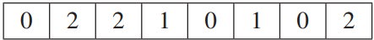
Figure 2 – Illustration of a chromosome

2. Fitness Function
The fitness function evaluates the number of conflicts that might exist among adjacent vertices which have the same color. In order to compute this value we simply find adjacent vertices from the graph adjacency matrix and check their color number in the integer array of the individual. Therefore, the total number of color conflicts is the result of the fitness function. When the result is equal to zero, a solution is found.

3. Reproduction and Crossover
Reproduction takes place amongst a number of fittest individuals of each group and amongst fittest individuals of different groups. The chosen individuals are then passed to crossover as parents of new individuals. To produce each new child, the crossover operator randomly chooses a pivot. It then finds the vertex colors of the first parent’s vertices which have a vertex number less than or equal to the pivot and concatenates them with the vertex colors of the second parent’s vertices which have a vertex number greater than or equal to the pivot. Figure 3 shows an example of the crossover with a pivot equal to 2 on two individuals of a five-vertex graph coloring problem.
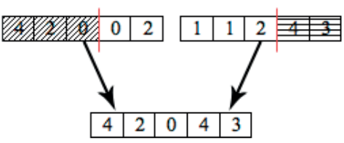
Figure 3 - Example of crossover

The reproduction and crossover operations are performed under the influence of the belief space. To proof this, we already rely on the fact that each individual in the population has number of colors less than or equal the general belief.

2.4 Experiments
We will focus on experimenting the Fitness and the General Belief among generations. The first experiment conducted will show the effect of mutation and weak self-adaptiveness on a small population for a graph with 30 nodes and 339 edges and stagnation tries of 60.

